Curriculum Vitaé
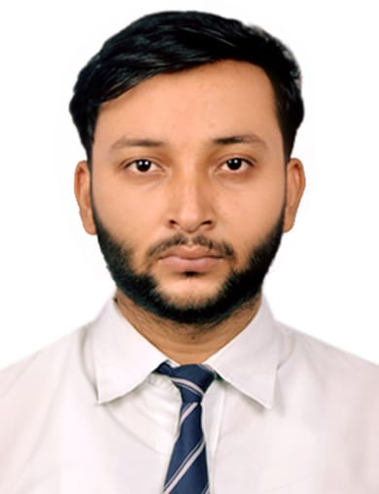

Name : Arif Khan
Address : MH-235 B, Azad Nagar, Maithon (Dhanbad) 828207
Mobile No : 7098644930

E-mail : arifkhanesm@gmail.com

Academic Qualifications:

Degree / Certificate | Qualification | Institute | Board /  University | Year | Aggregate % / CGPA
Post Graduation
Graduation | B. TECH (COMPUTER SCIENCE) | Bengal College of Engineering and Technology  Durgapur, West Bengal | MAKUT | 2019 | 7.3 CGPA
12th | INTERMEDIATE | D.A.V. CENTENARY PUBLIC SCHOOL, DHANBAD JHARKHAND | CBSE | 2014 | 64.5%
10th | MAATRICULATION | KENDRIYA VIDYALAYA OLD D V S BUILDING NEAR RLY CLUB ( E R) | CBSE | 2012 | 7.4 CGPA
Others

* Aggregate Marks mean Summation of the marks obtained in all the subjects (including optional subjects) divided by the total number of subjects.

Please mention any pending Backlogs in your Academic Career | No Backlog.

Trainings / Projects Undertaken:

Name of Institute / Organization | Project Title | Duration
KVCH, NOIDA | BLOOD DONATE (Python with Django Framework) | 45 DAYS
AICT, DURGAPUR | WEB DEVELOPMENT  (Advance Java with Oracle) | 28 DAYS

Additional Qualification / Achievements / Certifications:

- CERTIFIED FOR Industrial Skill based Training Program on PYTHON, from KVCH DELHI

Subjects of Interest:

- DBMS
Computer Proficiency:

- Basic C
- Core JAVA

Hobbies:

- Playing Guitar
- Photography

Personal Details:

Date of Birth : 22 October,1996
Gender : Male
Languages Known : English, Hindi.

Date: 17/08/2018

